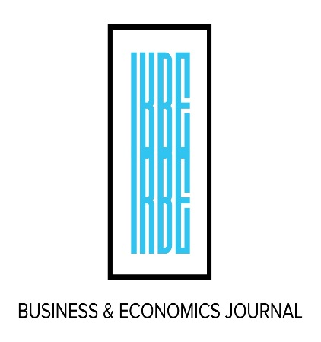
Conference Program
INDIAN ACADEMIC ISSUES
INDIAN KNOWLEDGE SYSTEMS
International Conference On

December 21-22, 2023
9:00 AM – 4:30 PM
at Auro University
Surat, India

Hotel Suggestion: Courtyard Marriott at the Earthspace

Organized & Sponsored by

International Review of Business & Economics (IRBE), Denver, CO
Auro University, Surat, India

Co-Sponsored by
Society of Indian Academics in America (SIAA)
Bhandarkar oriental research institute-pune
Bhaskarachrya pratisthan - pune
Veer Narmad South Gujarat University, Surat

Day 1: Thursday December 21, 2023
Program Schedule
9:30 – 9:45 AM
9:00 – 9:30 AM
Registration and Assembly
Welcome and Introduction
Dr. Kishore G. Kulkarni
Editor, International Review of Business and Economics (IRBE) and Distinguished Professor of Economics, Metropolitan State University of Denver, Denver. And Dr. Parimal Vyas, Vice Chancellor, auro university, Surat

Conference Keynote Speaker
Topic: Nurturing Bharatiya Knowledge System and Fostering Economic Prosperity: India’s Path to Global Significance.
Dr. SURESH GOSAVI
VICE CHANCELLOR, SAVITRIBAI PHULE PUNE UNIVERSITY (SPPU)
Questions and Answers to follow

Coffee & TEA BREAK [15 MINUTES]

9:45 – 10:45 AM

10:45 – 11:00AM
Session 1: INDIAN ECONOMIC GROWTH
Auditorium no - 1
Session Chair: Anand Kulkarni, Head of Research Centre for Optimism, Melbourne, Australia
- Vijay Gondaliya, Institute of Management Department of Management and Commerce, UKA Tarsadia University, “Growth and Foreign Direct Investment (FDI) in India”
- Anand Kulkarni, Private Consultant, and Head of research, Centre for Optimism, Melbourne, Australia, “Remittances and India’s Economic Development”
- Sudhanva Char, Research, Nutrition, & Dietetics, Life University, “Should India Lend to GDH the Same Weight as to GDP?”
Discussant: Sudhanva Char, Life University, Atlanta, Georgia

11:00 AM –
12:30 PM

11.00 to 12.30 ( 21/12/2023 )
Indian knowledge systems (Session no-1)
Auditorium no--2
Session Chair: Amartya kumar dutta – Indian Statistical institute-kolkata
- Amartya kumar dutta-indian statistical institute- ancient Indian mathematics-glimpses
- Shreenand bapat- Bhandarkar oriental institute-pune- research menthodology for iks.
- Dattatreya tapkeer – sndt college of education – pune-exploring the horizons of indianness in Indian education
Discussant : Dattatreya tapkeer
12:30 – 1:15 PM
Buffet Lunch Break [45 MINUTES]

11:00 AM –
12:30 PM
Session 2: DRUG ABUSE, OPIOD AND TRANSHUMANIST JOURNEY
Auditorium no--3
Session Chair: JOHN CHIRAMEL, COLUMBIA UNIVERSITY, NEW YORK
- Dhaval Dave (Presenter), Bilge erten, Pinar Keskin, & Shuo Zhang, Bentley University & National Bureau of Economic Research, Northeastern University, Wellesley College, & Northeastern University, “The Spillover Effects of Opioid Policies on Intimate Partner Violence”
- John Chiramel, Columbia University, New York, “The Transhumanist Journey – Is India Ready?”
- Purbita Jana, Visiting Scientist, Indian Statistical Institute (ISI), Kolkata, “Generalized Geometric Logic and Its Applications”
Discussant: Amitabh Dutta, Florida Institute of Technology, Melbourne, FL

Session 3: Help for Higher Education
Auditorium no-1
Session Chair: Kiran Pandya, Veer Narmad South Gujarat University, Surat
- Kiran Pandya & Prakash Bacharwala, UKA Tarsadia University & Academic Registrar, Veer Narmad South Gujarat University, “Some Issues and Challenges in Providing Financial Assistance to Disadvantageous Groups of Society for Higher Education”
- Shawn Worthy, Faculty Athletics Representative, Metropolitan State University of Denver, CO, “Potential Ways to Address University Student Mental Health Support in India”
- Prashant Vadikar, Government Arts and Commerce College, Anha-Dang, Gujarat, “Evaluating the Performance of Tax Policy: Tax Elasticity, Tax Buoyancy and Tax Stability”
Discussant: Shawn Worthy, Metropolitan State University of Denver, CO

1:15 – 2:45 PM

Indian knowledge systems ( session no-2)
Auditorium no -2
Session Chair: Ravindra kulkarni
- S. A. Katre, Bhaskaracharya Pratishthana, Pune, “Methods of Finding Square Roots in Ancient India”
- Ravindra Kulkarni, Bhaskaracharya Pratishthana, Pune, “Indian Knowledge System and Scientific Methodology”
3) Anuradha Choudary: coordinator iks division of aicte, ministry of education, govt. of india.- language as knowledge repositories: Sanskrit and its contributions.
Discussant: Anuradha choudhary

1:15 – 2:45 PM
1:15 – 2:45 PM
Session 4: Education Appraisal Issues
Auditorium no-3
Session Chair: Dhaval Dave, Bentley University, Boston, MA, and National Bureau of Economic Research (NBER)
- Nimesh Joshi & Punit Pathak, Professor, School of Business, and Coordinator Sri Aurobindo Integral Life Centre, Auro University & Assistant Professor, Auro University, “Integral Education in Context: An Analysis of Sri Aurobindo and The Mother’s Educational Views in the Light of NEP 2020”
- Kalyan Chakraborty, Lamar University, Beaumont, Texas, “Quality of Education and Economic Growth – A Case for India”
- Ushma K. & Jayesh N. Desai, Assistant Professor & Principal, BRCM College of Business Administration, “Appraising Perception Regarding New Skill Based Professional Curriculum of Business Administration”
Discussant: Jayesh N. Desai, Principal, BRCM College of Business Administration

Coffee & Tea Break [15 Minutes]

3:00 – 4:30 PM
Session 5: Global Trade and Pandemic Effects
Auditorium -1
Session Chair: Sudhanva Char, Life University, Atlanta, GA
- Amitabh Dutta & Kishore Kulkarni, Associate Professor of Finance, College of Business & Distinguished Professor of Economics, Chief Editor, International Review of Business and Economics, “Economic Effects of Pandemic on US and Indian Economies with Policy Actions in 2019 - 2023: A Comparative Analysis”
- Vijaya Subrahmanyam, Usha Nair-Reichert, & Penelope B. Prime, Associate Dean C. Mercer University, Associate Professor Director, master’s Program School of Economics, Georgia Institute of technology, & Founding Director, China Research Center Managing Editor, “India’s and China’s OFDI in South and Southeast Asia: Motivations & Results”
- Sudhakar Raju, Professor of Finance, Rockhurst University, Kansas City, MO, “Estimating Risk Aversion in International Asset Pricing Models”
Discussant: Kishore Kulkarni, Metropolitan State University of Denver, CO

2:45 – 3:00 PM

Session 6: Portfolio Analysis, Legal Issues, Business Sector, and Academic Research
Auditorium no-3
Session Chair: Michele M. Clark, Metropolitan State University of Denver, CO
(1) Krunal Patel, Assistant Professor, SRIMCA—MBA, UKA Tarsadia University, “Construction of an Optimal Portfolio Using Sharpe single Index Model on Indian Stock Market”
(2) Michele M. Clark, Associate Professor, Metropolitan State University of Denver, CO, “Using Alternative Dispute Resolution to Clear the Backlog in India’s Court System”
(3) Pratik Puprediwar & Poornima Tapas, Research Scholar, Symbiosis International & Professor, Symbiosis Institute of Business Management, Pune, “Why Are Businesses Not Considering Academic Research Worth?”
Discussant: Krunelkumar Patel, UKA Tarsadia University

3:00 – 4:30 PM

Day 2: Friday, December 22, 2023
9:30 AM – 11:00AM
Indian Knowledge Systems (session 3)
auditorium 2
Session Chair: Ambrish Khare, T.M.V., Pune
- Sudheer & Rajas Vaishampayan, B.O.R.I., “Reviving and Exploring the Scientific Foundations of Vaisheshika Darshana”
- Ravindra Godbole, B.O.R.I., “Recreating Ancient Astronomical Instrument - Astrolabe”
- Ambrish Khare, T.M.V., Pune, “Ayurveda: Ancient Indian Life Sciences”
Discussant: Ravindra godbole

11:30 – 1:00 PM
11:00 – 11:30 AM
Coffee & Tea Break [30 Minutes]

Indian knowledge System (session 4)
Auditorium --2
Session Chair: Pradeep Apte, B.O.R.I.
- Vijaya Deshpande, B.O.R.I., “Ancient Indian Rasayana Didn’t Deliver Gold. Or Did It?”
- Pradeep Apte, B.O.R.I., “Some Aspects of History of Food in Indian Continent”
- Girish Sarde, Consultant – Deenanath Mangeshkar Hospital, Pune “Magnitudes of Yoga from IKS for NEP”
Discussant: Girish Sarde, Consultant, Mangeshkar Hospital, Pune

Session 9: Business Policy Issues
Auditorium 1
Session Chair: Rajendra Khandekar, Metropolitan State University of Denver, CO
- A.D. Amar & Vivek Natarajan, Seton Hall University & Lamar University, “Putting the Worker Front and Center: Anthology from Arthashastra”
- Rajendra Khandekar, College of Business, Metropolitan State University of Denver, CO, “Political CSR: A Tale of Two Companies”

- Nimisha Jariwala, Teaching Assistant, Department of Management, UKA Tarsadia University, “The Succession Planning Practices Followed in the Family Businesses at Surat City”

- Jayesh N. & Ushma K. Desai, Principal & Assistant Professor, B.R.C.M College of Business, “Privatization of Higher Education in India: A Continuing Debate”
Discussant: A.D. Amar, Seton Hall University

11:30 – 1:00 PM

1:45 – 2:30 PM
Keynote address by Prof. Debasish Chakraborty, Associate Dean, College of Business, Seton hill university, Greensburg, PA Topic: Economic Drivers and Global South: New Leaders in Coming Decades

1:00 – 1:45 PM
Buffet Lunch Break [45 Minutes]

Closing Ceremony and Certificate Distribution
- Dr. Ajit Ranade, Vice Chancellor, Gokhale Institute of Politics and Economics, Pune, “Imperative of Sustained and Inclusive Growth in India.”

- Kishore G. Kulkarni, Program Chair, IRBE and Kiran Pandya, Professor of Economics, “Closing Remarks and Thanks”

3:00 – 4:30 PM
2:45 – 3:00 PM
Coffee & Tea Break [15 Minutes]

- PRESENTERS ARE REQUESTED TO Follow all the time LIMITS. Presentations can be no more than 20 minutes AND discussions can be up to 5-7 minutes.
- Session chair would make sure that the session runs smoothly AND session chairs WOULD ACT AS THE JUDGE IN ANY disagreements.
- CONFERENCE allows power point presentation. if there are any problems, ask the student volunteers to help.
- Clarification of any kind about the facilities should be done with the CONFERENCE MANAGEMENT.
- please put off cell phones when the sessions are in progress. If you must answer the call please leave the room quietly
- if you are coming to hotel from outside, please respect (and recognize the hardships of) SURAT traffic and give yourself extra minutes to reach on time.
- For your travel needs we recommend Mr. Prathamesh Lad of RUTVA HOLIDAYS Travel at prathamesh@rutvaholidays.com
- Friends, other researchers and Family of participants can attend the conference at the rate of Rs. 1,000/- per day and Rs. 2,000/- for both days. They need to register at least one week in advance.
- Discussants will make comments on all papers in the session in 2-3 minutes each. questions and answers from the audience need to end when the time allotted to each session is over.
10)Please make sure that you attend all sessions on BOTH days; unless excused by the Program Committee.

See you in next IRBE/SIAA conference In December 2024.

Notes to Participants:
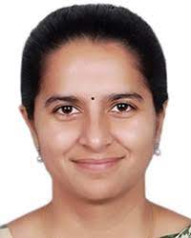 | 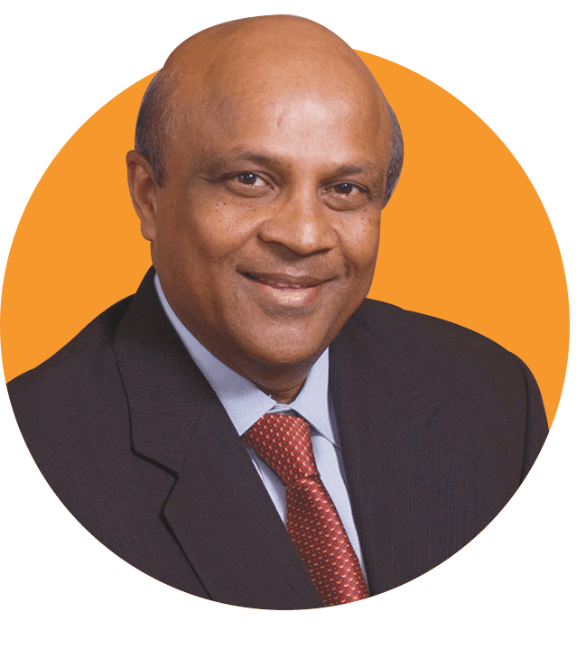 | 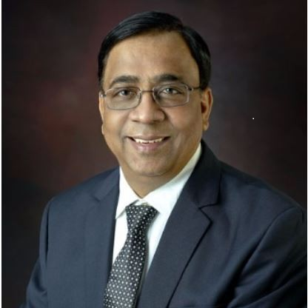
Dr. Anuradha Choudry  IKS Division, Ministry of Education, Govt. of India | Mr. Hasmukh (H. P.) Rama  Founder President,  AURO University, Surat | Professor Parimal H. Vyas  Provost, AURO University, Surat

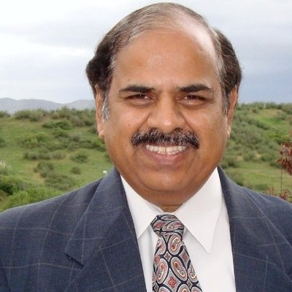 | 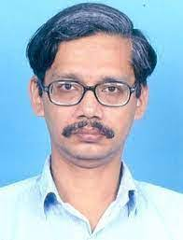 | 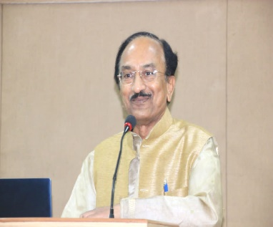
Kishore Kulkarni Distinguished Professor, MSU Denver | Prof. Amartya Kumar Dutta  Indian Statistical Institute, Kolkata | Dr. Dattatreya Tapkeer  SNDT College of Education, Pune

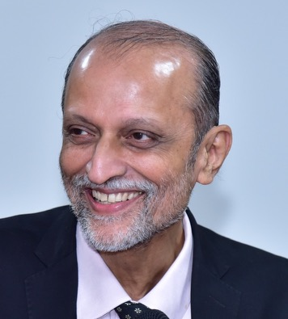
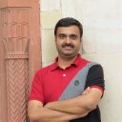
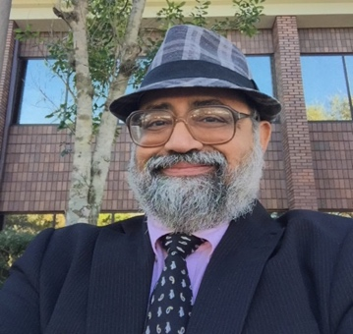
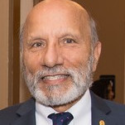
Ajit Ranade Vice Chancellor, Gokhale Institute of Politics and Economics
Ambrish Khare Assistant Professor, T.M.V.
Amitabh Dutta Associate Professor, Nathan M. Bisk College of Business
A.D. Amar Business Professor, Seton Hall University

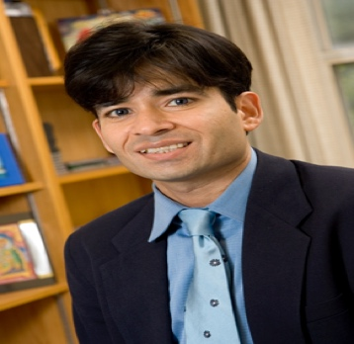
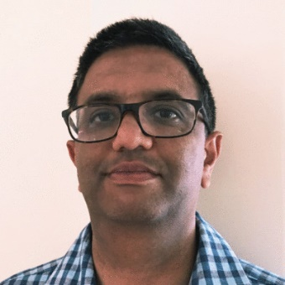
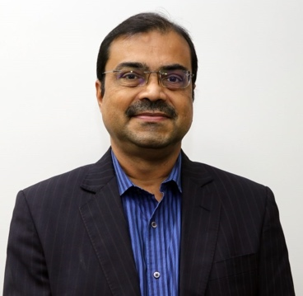
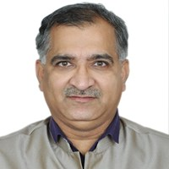

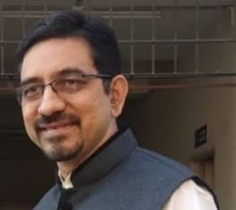
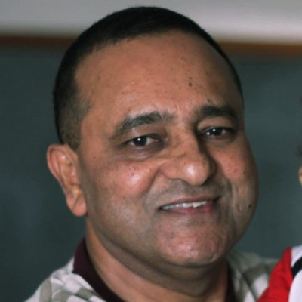
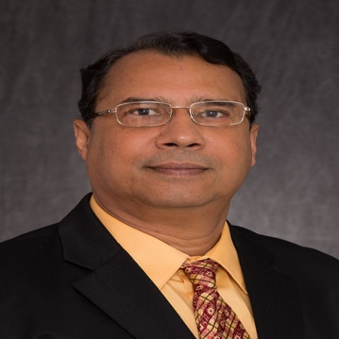
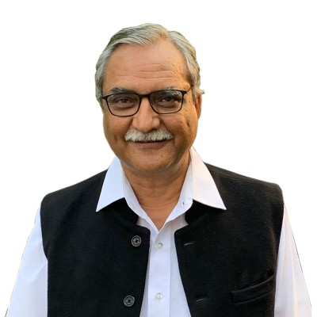

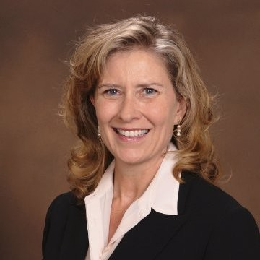
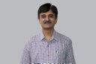
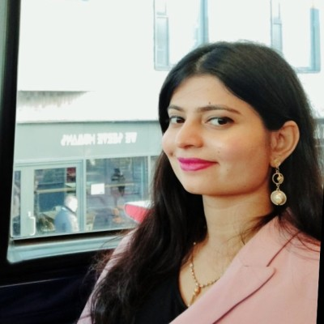
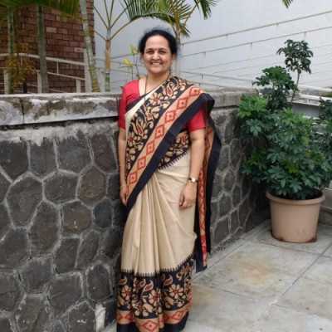
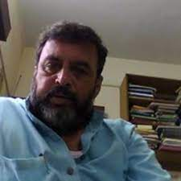
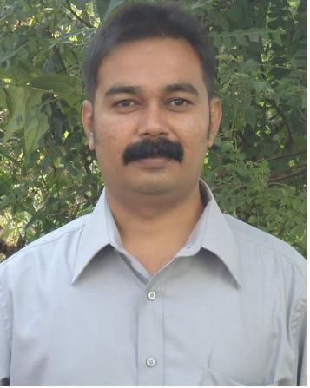
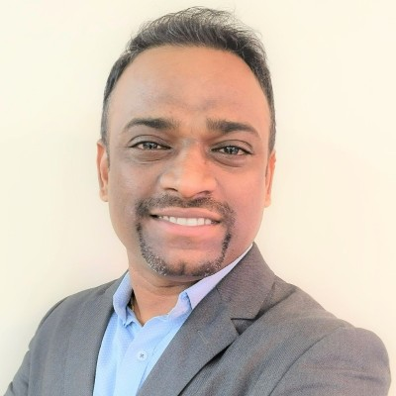
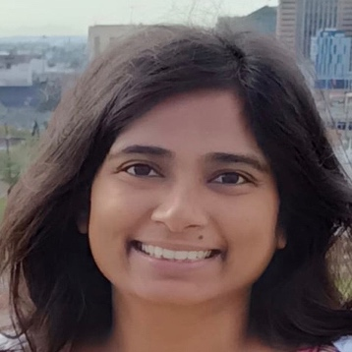
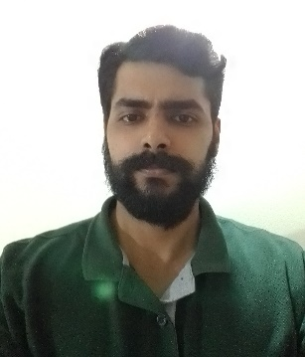
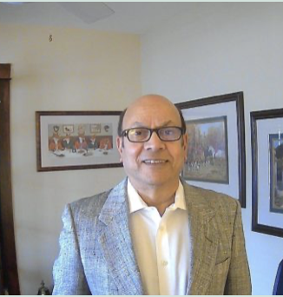
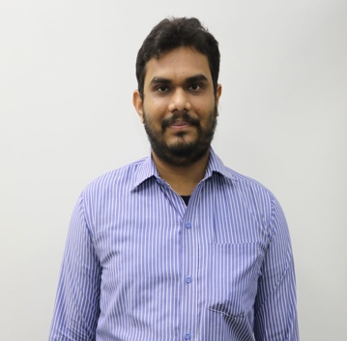
Anand Kulkarni Co-Head of Research, Centre for Optimism
Dhaval Dave Economics Professor, Bentley University
Gaurav Ashesh
Head, School of Business,
AURO University
Girish Sarde Consultant, Deenanath Mangeshkar Hospital
Jayesh N. Desai Principal, B.R.C.M. College of Business Administration
John Chiramel Visiting Professor, XLRI School of Management
Kalyan Chakraborty Economics Professor, Lamar University
Kiran Pandya Dean, UKA Tarsadia University
Krunal Patel Assistant Professor, UKA Tarsadia University
Michele M. Clark Associate Professor, MSU Denver
Nimesh Joshi Business Professor, AURO University
Nimisha Jariwala Teaching Assistant, UKA Tarsadia University
Pratik Puprediwar Research Scholar, Symbiosis International University
Poornima Tapas Professor, S.I.B.M.
Pradeep Apte Professor, B.O.R.I.
Prakash Bacharwala Academic Registrar, Veer Narmad South Gujarat University
Purbita Jana Visiting Scientist, Indian Statistical Institute (ISI)
Rajas Vaishampayan Professor, B.O.R.I.
Rajendra Khandekar Management Professor, MSU Denver
Punit Pathak Assistant Professor, AURO University
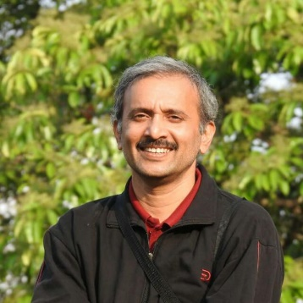
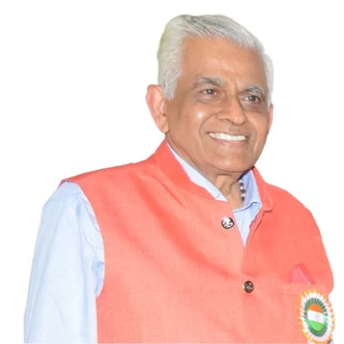
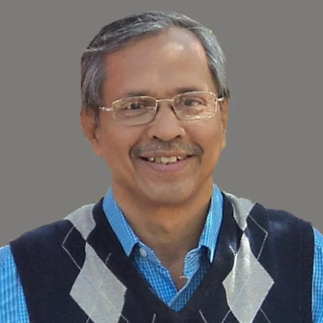
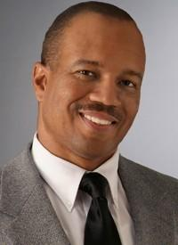

Ravindra Godbole Professor, B.O.R.I.
Ravindra Kulkarni Distinguished Professor, Bhaskaracharya Pratishthana
S.A. Katre, Professor, Bhaskaracharya Pratishthana
Shawn Worthy Athletics Representative, MSU Denver

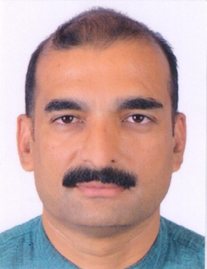
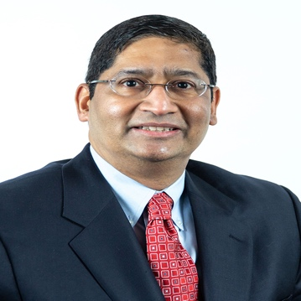
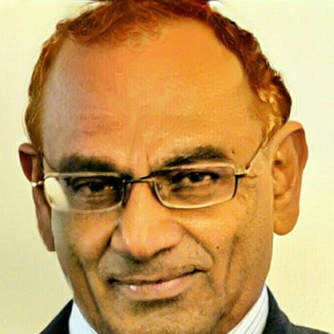
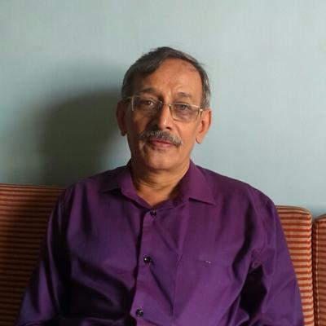

Shreenand Bapat Registrar, B.O.R.I.
Sudhakar Raju Professor, Rockhurst University
Sudhanva Char Professor, Life University
Sudheer Vaishampayan Professor, B.O.R.I.
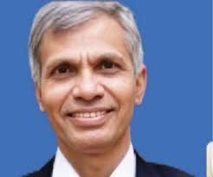
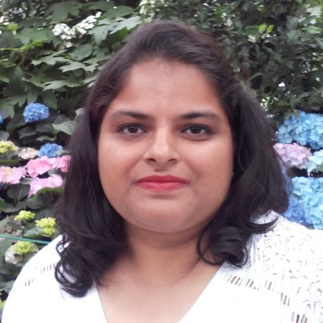
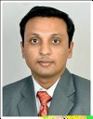
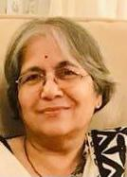
Suresh Gosavi Vice Chancellor, Savitribai Phule Pune University (SPPU)
Ushma Desai Assistant Professor, B.R.C.M. College of Business Administration
Vijay Gondaliya Director, UKA University
Vijaya Deshpande Senior Researcher, B.O.R.I.
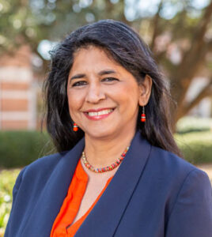
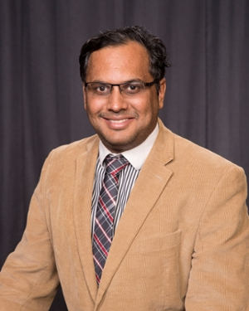
Vijaya Subrahmanyam Associate Dean, Mercer University
Vivek Natarajan Marketing Professor, Lamar University

