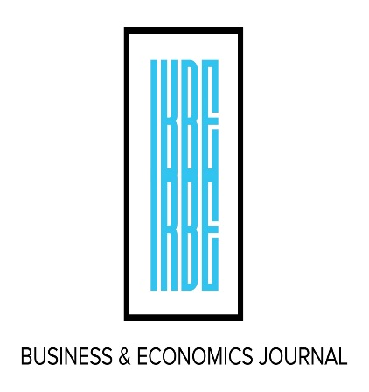
Conference Program
INDIAN ACADEMIC ISSUES and Indian Knowledge System (IKS)

International Conference On

November 15-16, 2024
9:00 AM – 4:30 PM
at Holiday inn hotel
Houston tx

Organized & Sponsored by
Society of Indian academics in America (Siaa)
International Review of Business & Economics (IRBE), Denver, CO

Day 1: November 15, 2024
Program Schedule
Registration and Assembly
Welcome and Introduction
Dr. Kishore G. Kulkarni
President, siaa and Distinguished Professor of Economics, Metropolitan State University of Denver, Denver

9:30 – 9:45 AM
9:00 – 9:30 AM
Speaker: Dr. Rohit Parikh
Topic: A model for the capability approach

9:45 – 10:30 AM
10:30 – 11:15 AM
Speaker: Sree Sreenath
Topic: Trouble in Paradise: Portending Winds of Sanatana Dharma in US

Speaker: niloufer Sohrabji and neetu Kaushik
Topic: Analyzing the Impact of India – U.S. Trade on India’s Manufacturing and Agriculture Sectors

11:15 AM – 12:00 PM

12:00 – 1:00 PM
LUNCH: Will be Provided

1:00 – 1:45 PM
Speaker: Hrishikesh Vinod
Topic: August 2024 buy-sell guide for nifty 29 Indian stocks and modified omega criterion (VIA Zoom)

1:45 – 2:30 PM
Speaker: Sudhanva Char
Topic: Is Indian Economy on Autopilot?

Coffee Break
2:30 – 3:00 PM

Speaker: Jitesh Chandra Saha
Topic: Indian Railways Haulage – A Cost Revenue Perspective

Speaker: Dhanamanjiri sathe
Topic: Why are Indians Unemployed?

3:00 – 3:45 PM

3:45 – 4:30 PM

*Evening is free but if you need company or things to do, ask Vivek Natarajan*

Day 2: Friday, November 16, 2024

Speaker: Milind Sabnis
Topic: Vande Mataram. History and Inspiration

9:00 – 9:45 AM

9:45 – 10:30 AM
Speaker: ravindra Kulkarni
Topic: Euclid’s fourth postulate: A modern perspective

10:30 – 11:15 AM
Speaker: kishore Kulkarni and Amitabh dutta
Topic: exchange rate determinants and India’s rupee fluctuations

11:15 AM – 12:00 PM
Speaker: Rashmi Umesh
Topic: Finance and Women Empowerment in India: Can Financial Literacy Help?

12:00 – 2:00 PM
LUNCH: Will be Provided

Speaker: Vivek Natarajan & Co-Author
Topic: Marketing Experiments and Results

2:00 – 2:45 PM

Closing Ceremony
2:45 PM
- PRESENTERS ARE REQUESTED TO Follow all the time LIMITS. Presentations can be no more than 30-35 minutes AND discussions can be up to 5-7 minutes.
- CONFERENCE allows power point presentation. if there are any problems, let vivek Natarajan know
- please put off cell phones when the sessions are in progress. If you must answer the call please leave the room quietly
- if you are coming to hotel from outside, please respect the hotel uidelines
- Please make sure that you attend all sessions on BOTH days; unless excused by the Program Committee.

See you in next IRBE/SIAA conference In November 2024.

Notes to Participants:
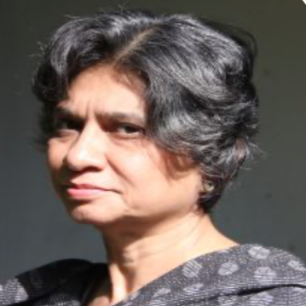
Dhanamanjiri Sathe Professor, Gokhale Institute of Politics and Economics
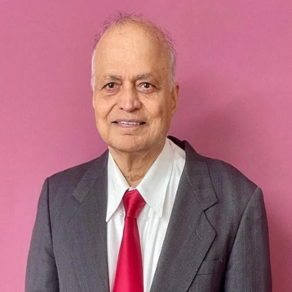
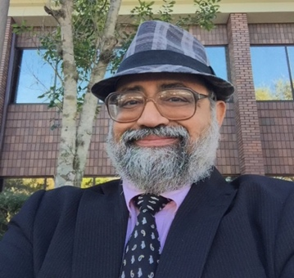
Hrishikesh Vinod Professor of Economics, Fordham University
Amitabh Dutta Associate Professor, Nathan M. Bisk College of Business

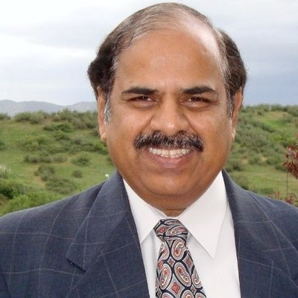

Milind Sabnis Independent Researcher

Jitesh Chandra Saha Assistant Professor, Govt. Degree College, Kamalpur

Dr. Kishore Kulkarni Distinguished Professor, MSU Denver

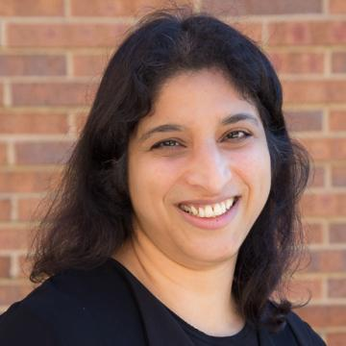
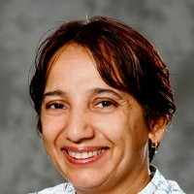

Niloufer Sohrabji Professor, Simmons University

Neetu Kaushik N/A

Rashmi Umesh Associate Professor, Bradford University, UK

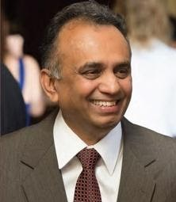
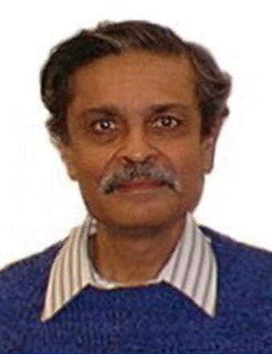
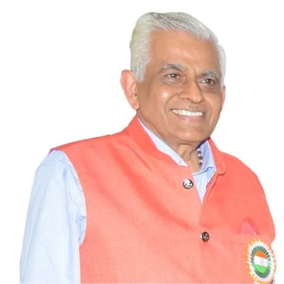

Dr. Sree Sreenath President, Vivekananda Yoga University

Dr. Rohit Parikh Distinguished Professor, Brooklyn College

Ravindra Kulkarni Distinguished Professor, Bhaskaracharya Pratishthana

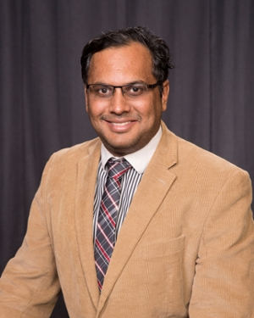
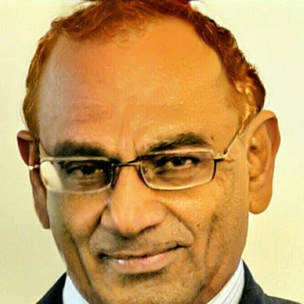

Vivek Natarajan Marketing Professor, Lamar University
Sudhanva Char Professor, Life University

