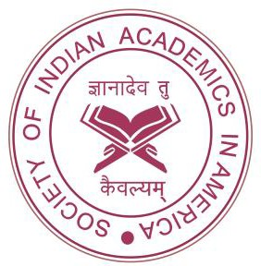
Society of Indian Academics in America
Registered Non profit organization. www.siaaus.com
(a 501 (c)(3) approved not for profit organization) Established in 1987. New Members Are Welcome to Join.

Dear Friend/s:

It is my pleasure and privilege to invite you to present a completed research paper on any Indian academic issue in SIAA’s upcoming conference on 15-16, November 2024. As the President of SIAA since 2023, I am excited to make Houston conference a grand success with the help of conference committee members, Dr. Vivek Natarajan, who is the local area coordinator, and Secretary of SIAA. You will not only meet other researchers interested in India studies, but also have an opportunity to expand your knowledge base with the help of interactions. We shall invite some eminent speakers for plenary sessions. SIAA is a vibrant organization with monthly webinar series that is ongoing for last 3 years. If you know someone who can present a webinar, let me know.

Please see the attached “Call for Papers” that has more information about the conference. I eagerly look forward to receiving your paper submission.

Hope we can meet in Houston in November.

Sincerely yours,

Kishore G Kulkarni, Ph.D,
President, Society of Indian Academics in America (SIAA)
See www.siaaus.com Distinguished Professor of Economics,
Metropolitan State University of Denver, P. O. Box 173362, CB 77
Denver, CO 80217-3362

